Home Page

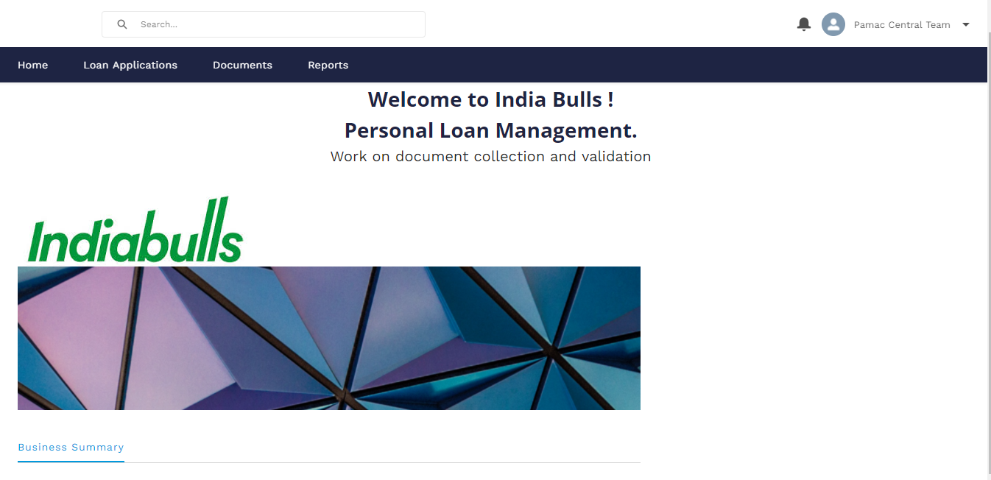

Click on Loan Applications to view the document list

From the list view the Image QC team member will select the list of leads pending for image QC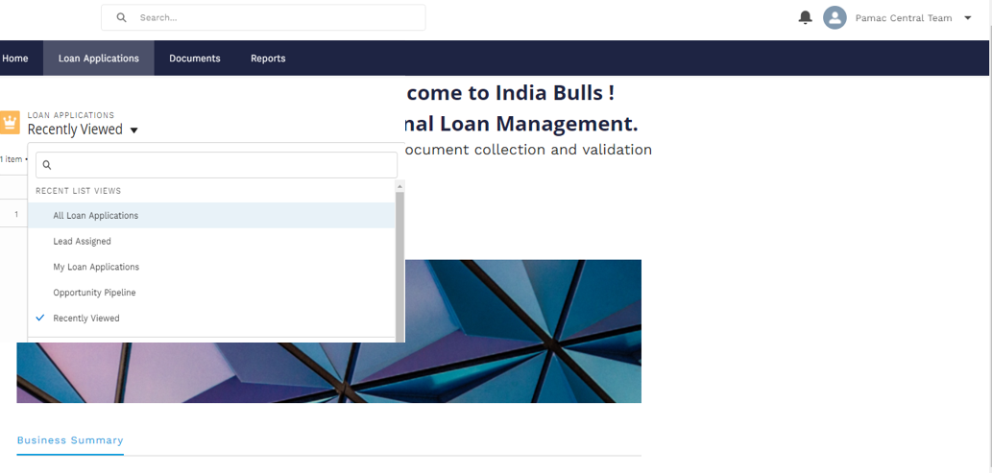

Lead level view – click on related to view the documents

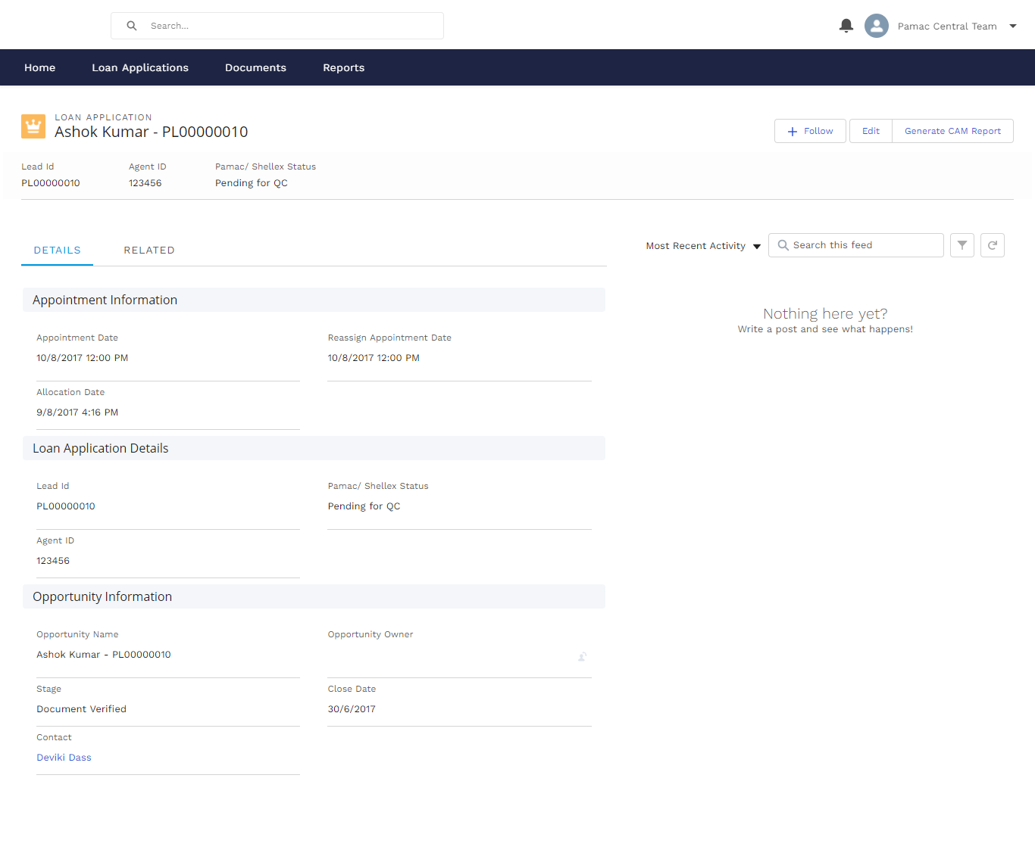

Related tab view

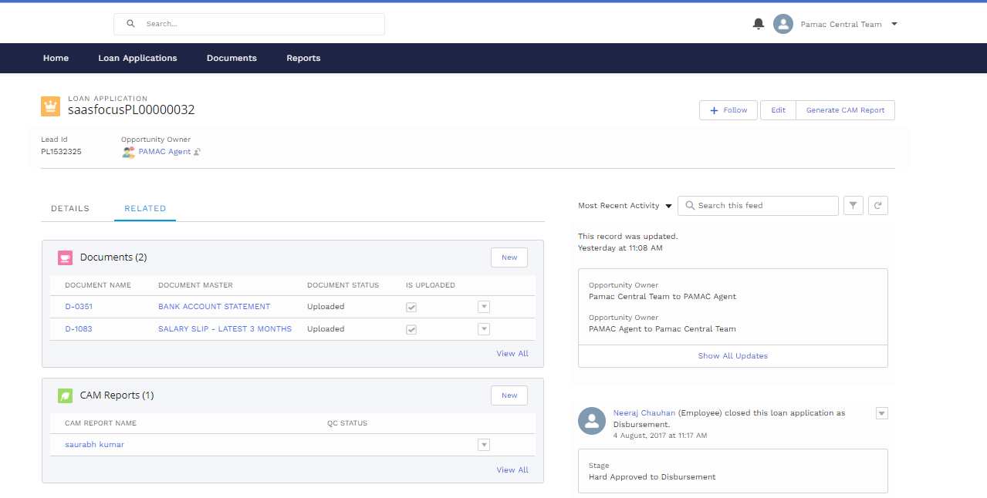

Image QC team member will click on the document name to view the images uploaded against it

Image view list inside document

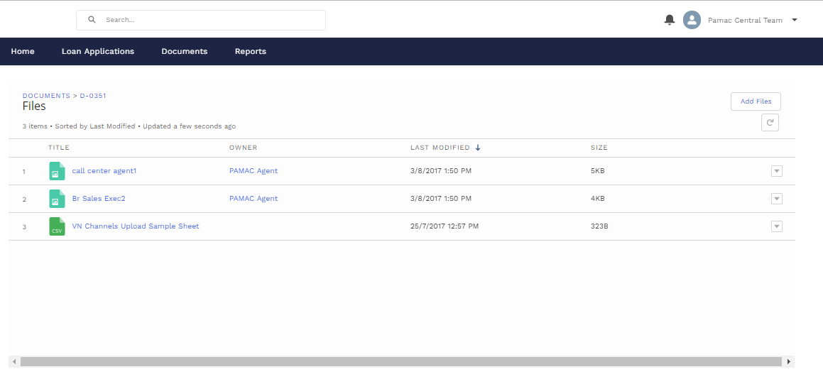

From the related tab view, the image QC team member will click on edit to update the document status, from the PAMAC/Shellex status drop down the image QC team member will update the status as Image QC completed

